**PSPP LAB**

**SUBJECT CODE : 21CS102**

**EXPT.NO: 2**

* **PYTHON PROGRAMMING USING SIMPLE STATEMENTS AND EXPRESSIONS.**

**NAME : SAFEERUL HASAN M**

**ROLL.NO : 22CSEA57**

**CLASS : I CSE A**

**DATE : 02.12.2022**

**a)EXCHANGE OF VALUES USING THIRD VARIABLE (NATIVE APPROACH)**

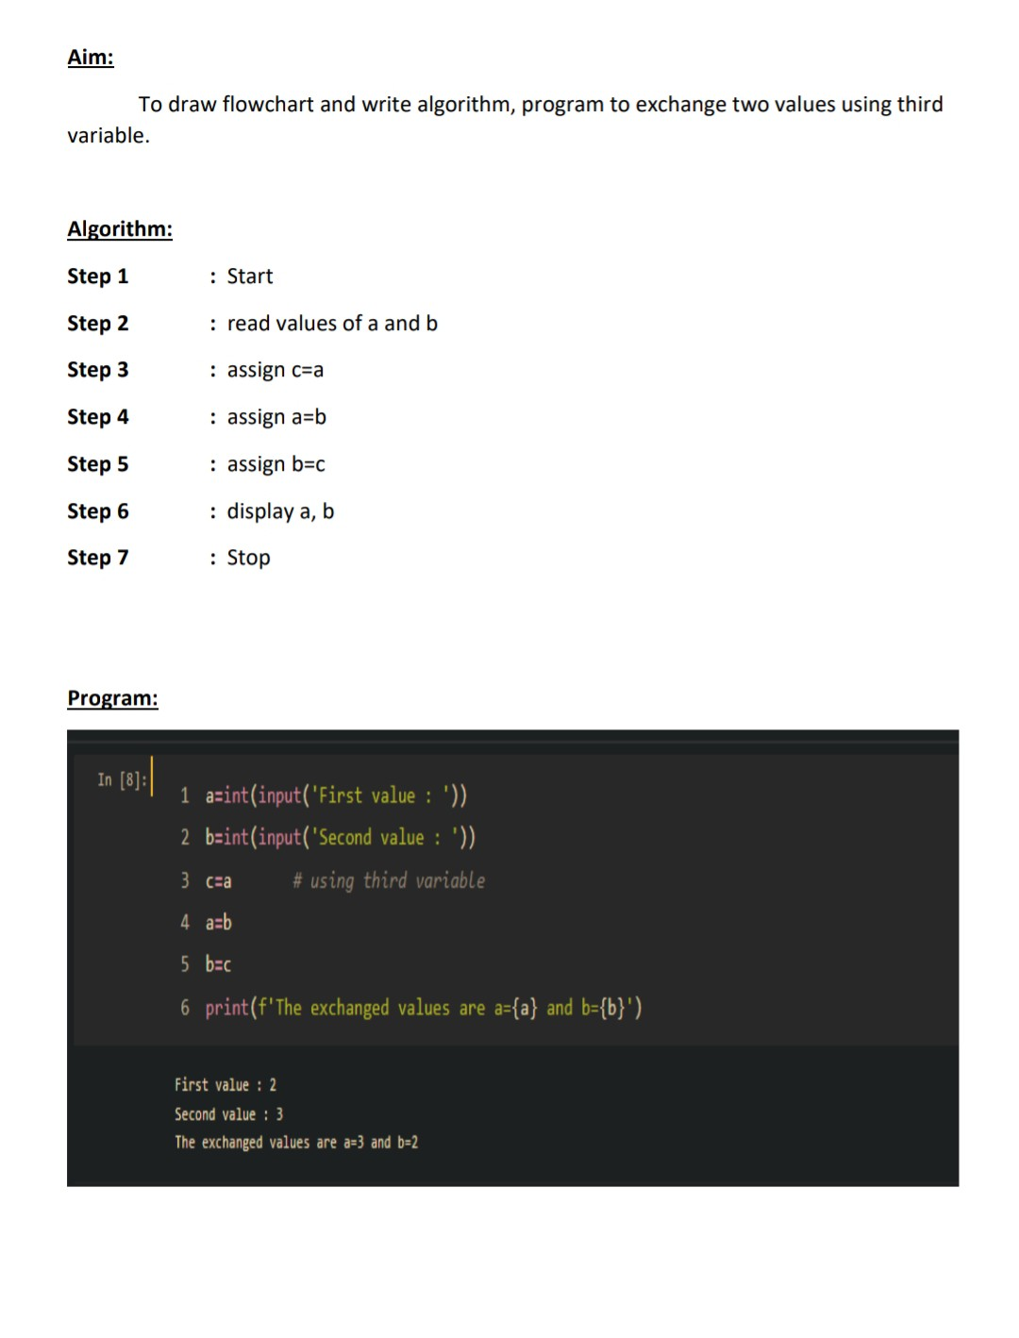

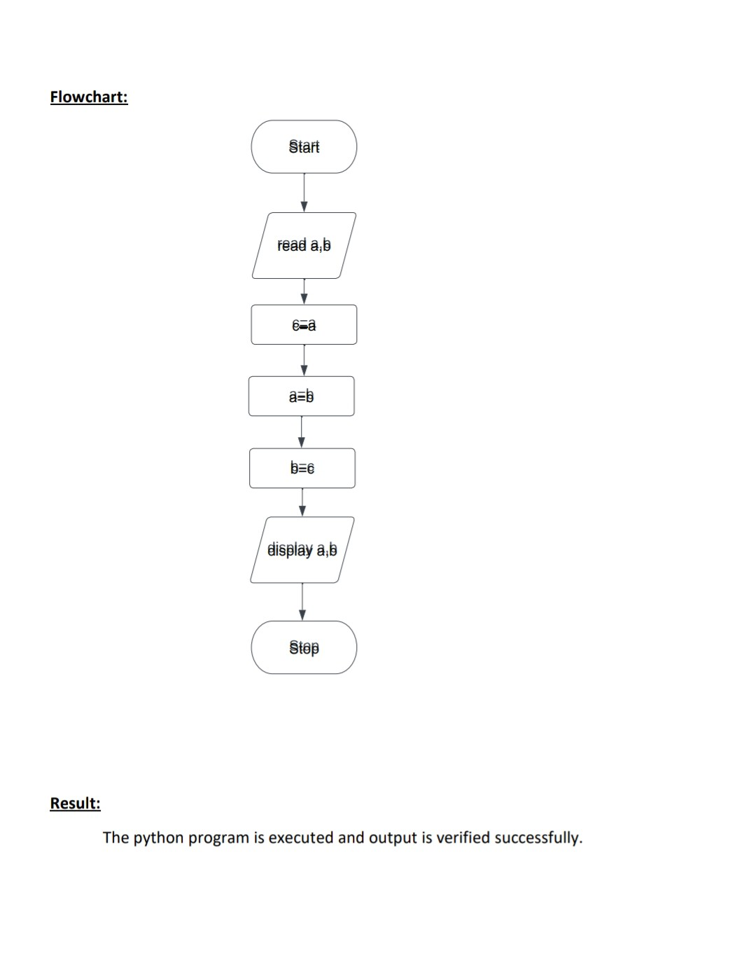

**b)EXCHANGNG TWO VALUES USING COMMA(,) OPERATOR**

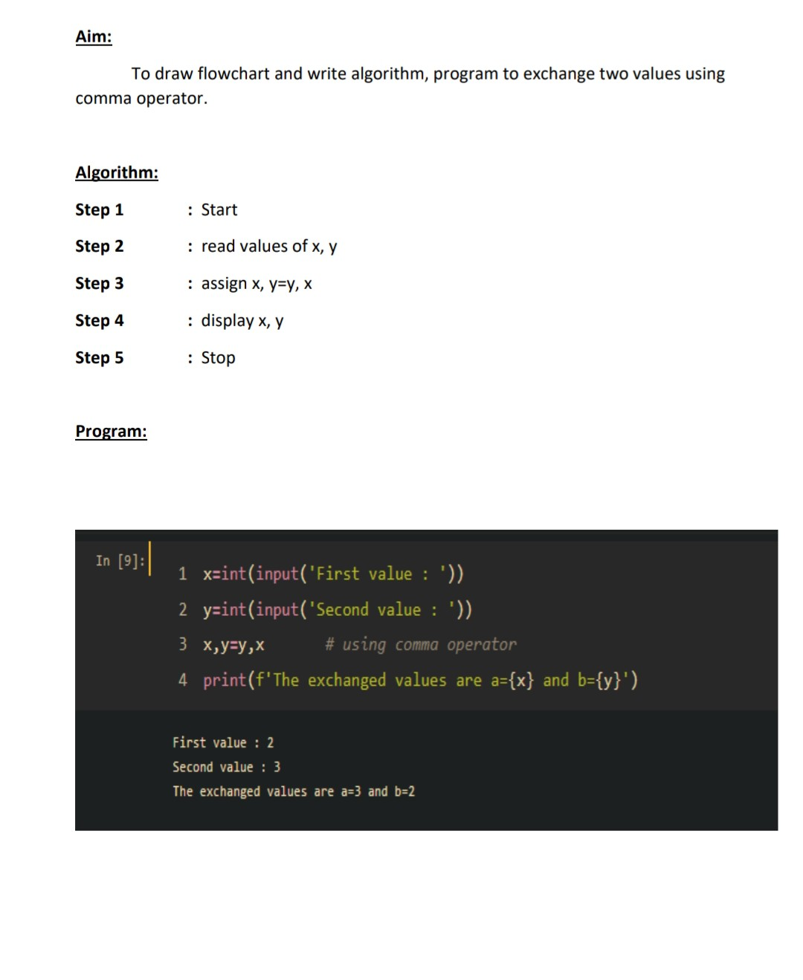

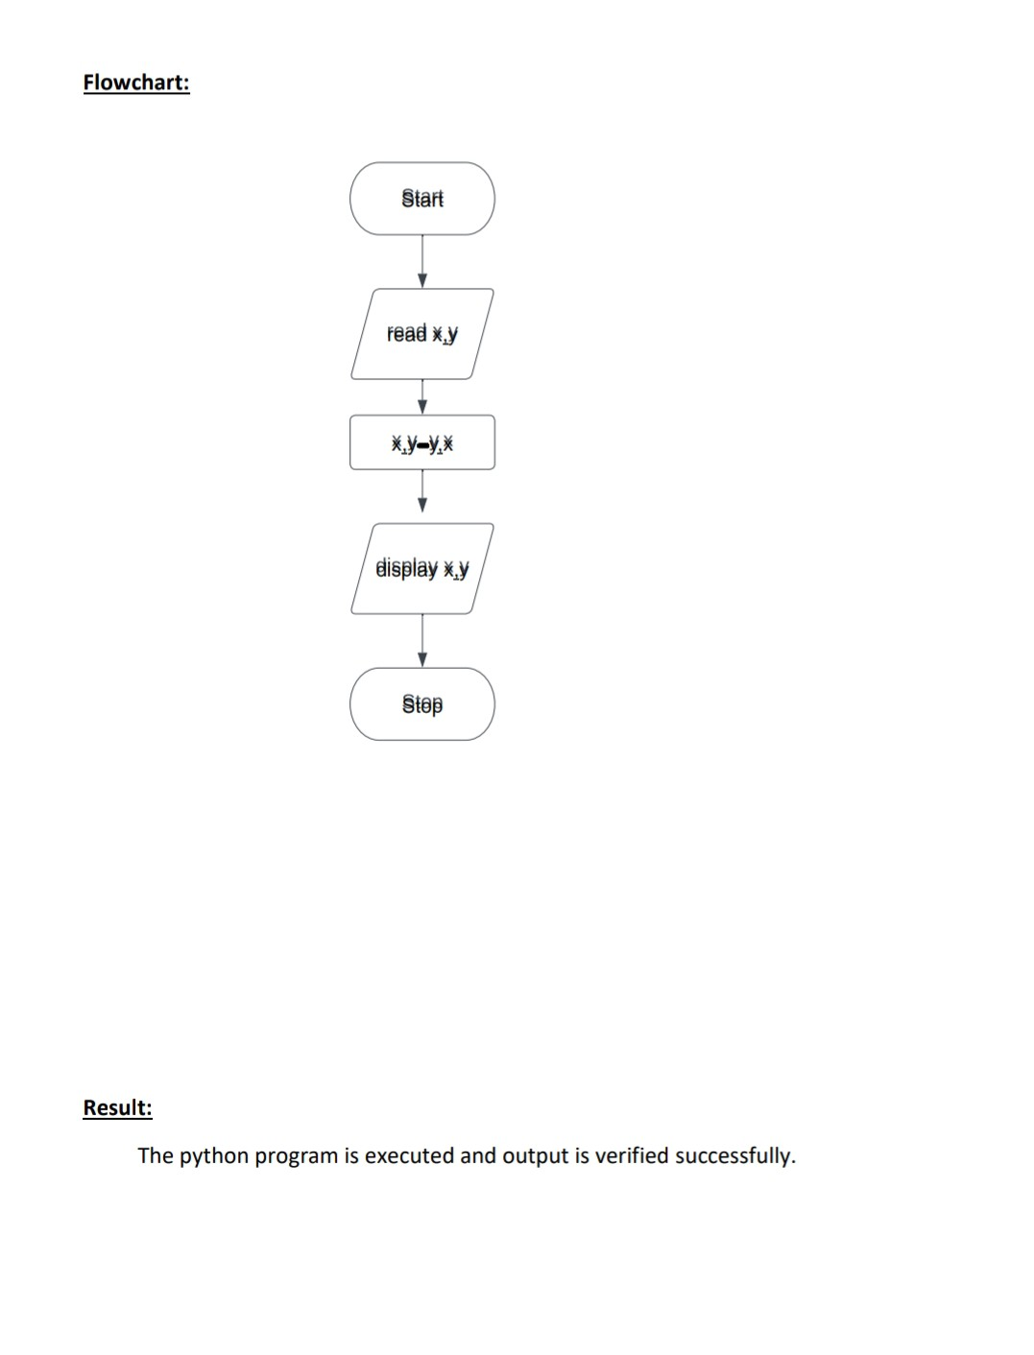

**c)EXCHANGING VALUES USING ARITHMETIC OPERATOR**

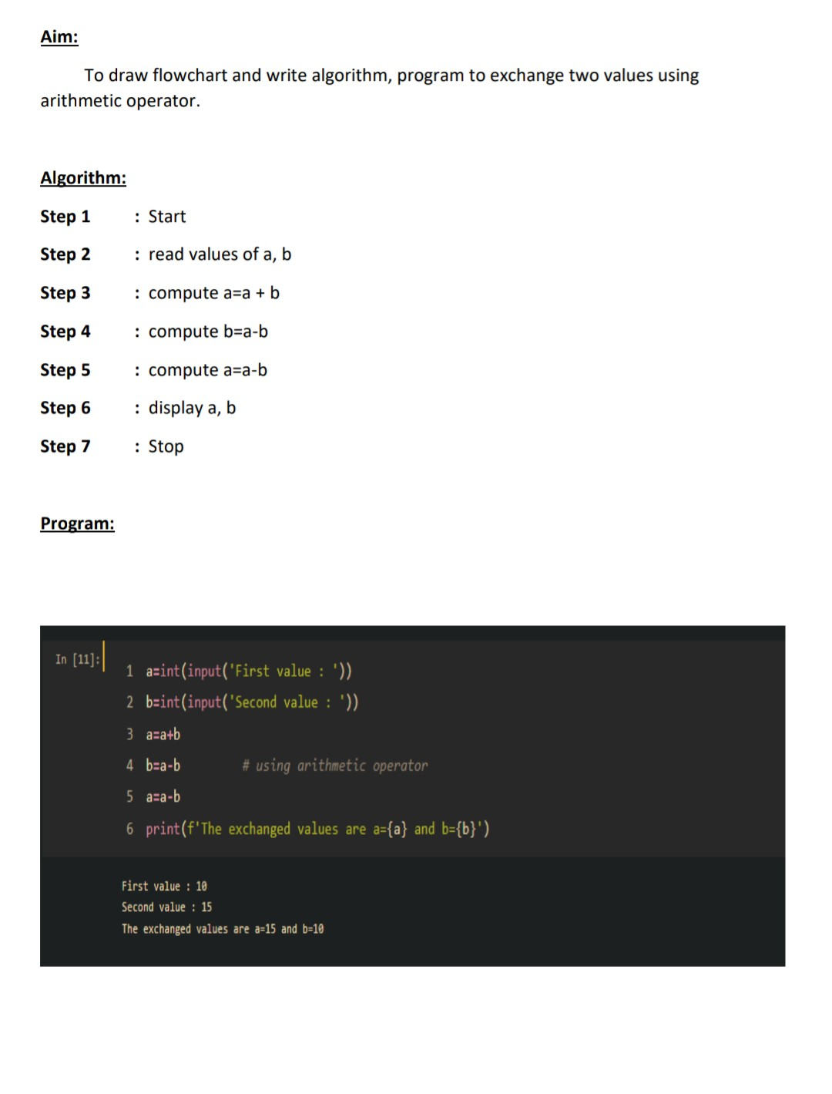

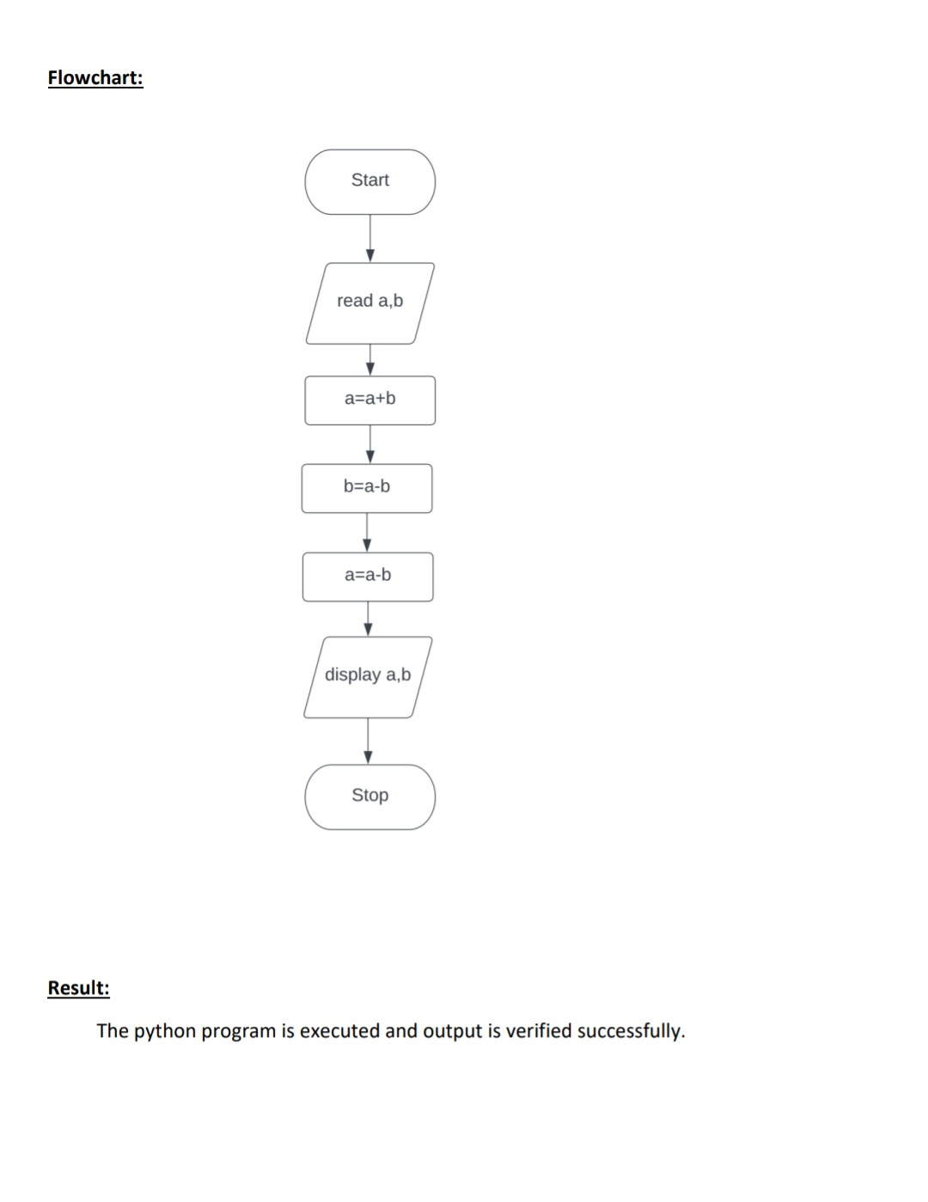

**d)EXCHANGING 2 VALUES USING XOR OPERATOR**

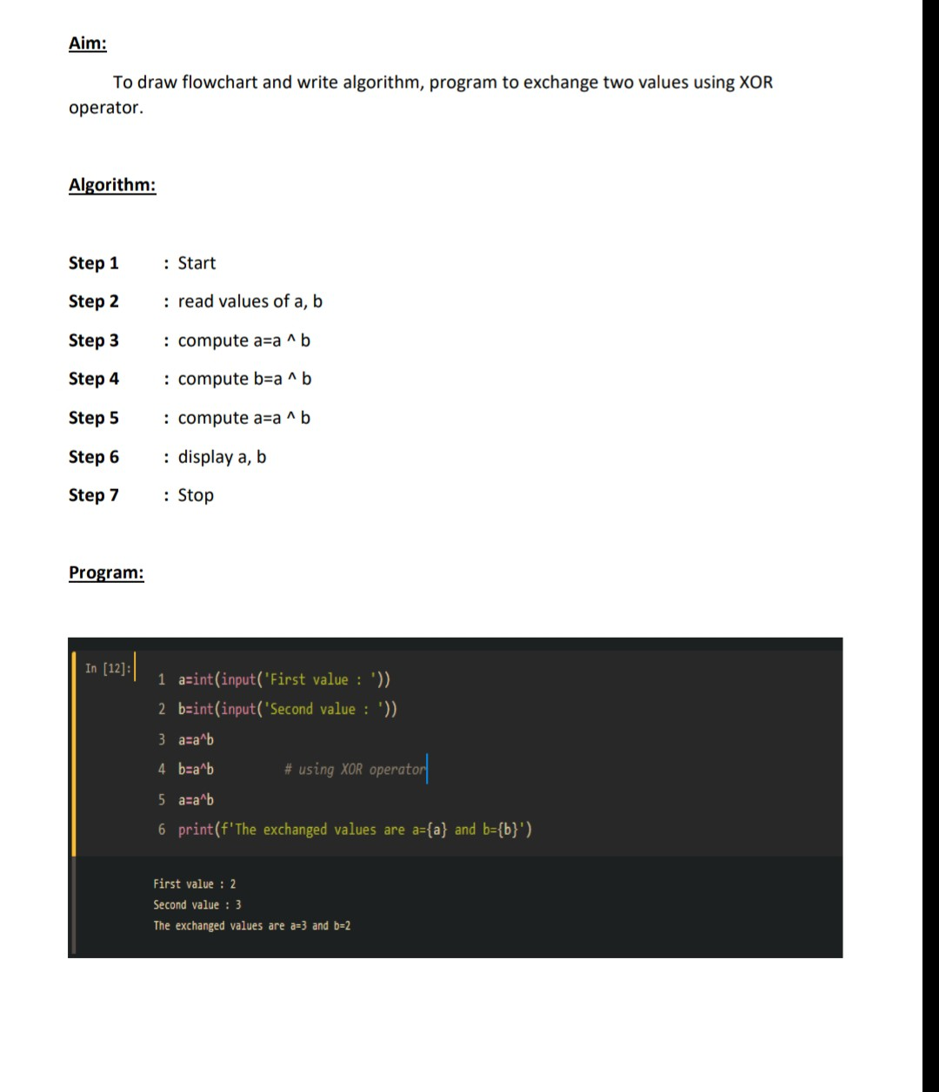

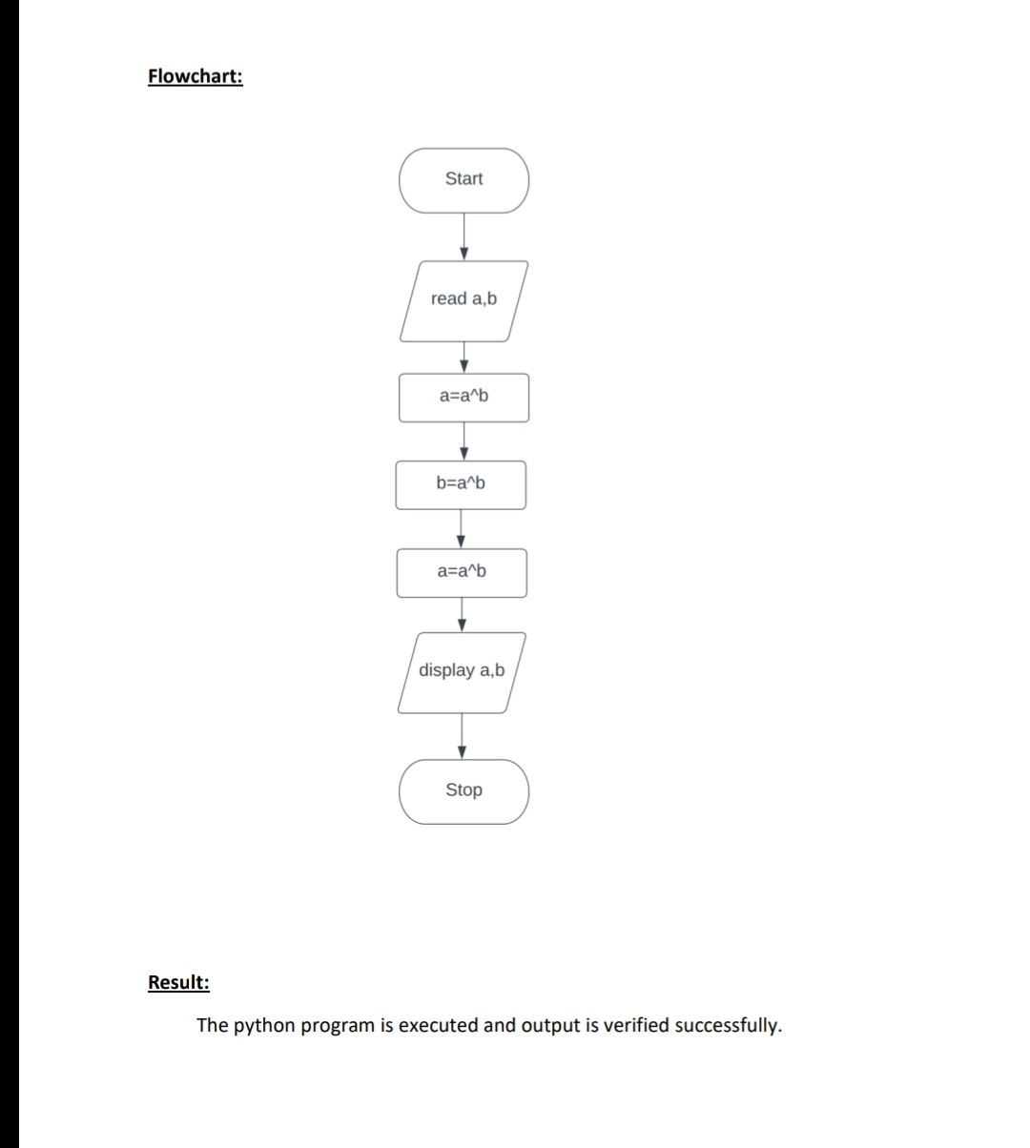

**e)CIRCULATING THE LIST OF VALUES USING in-BUILT FUNCTION**

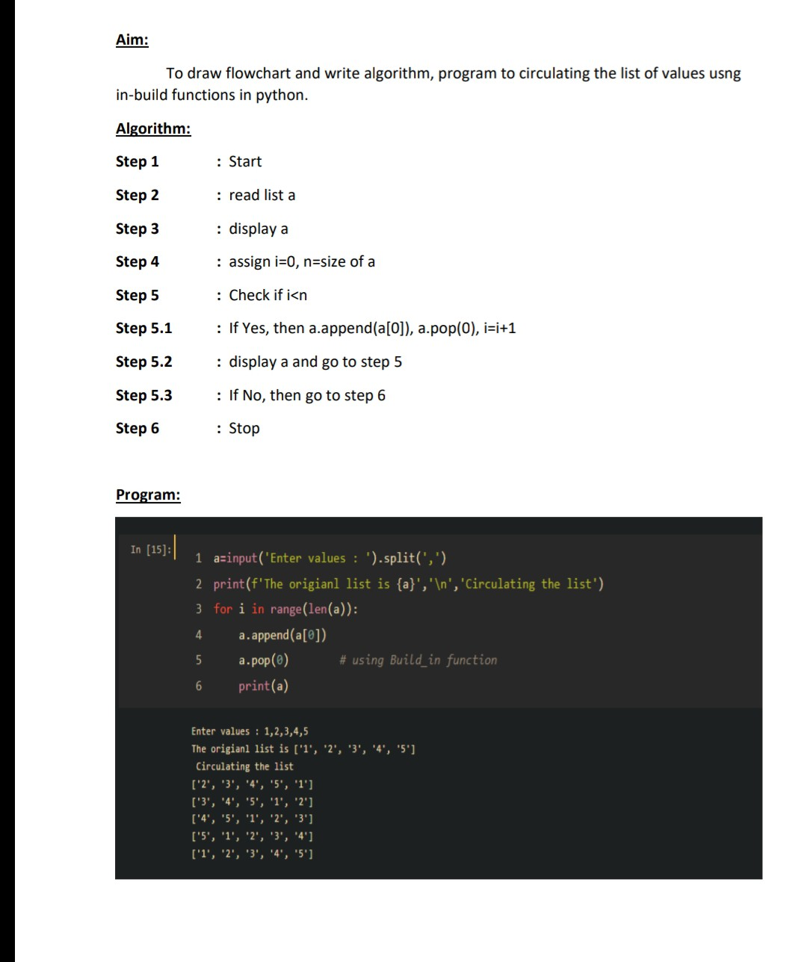

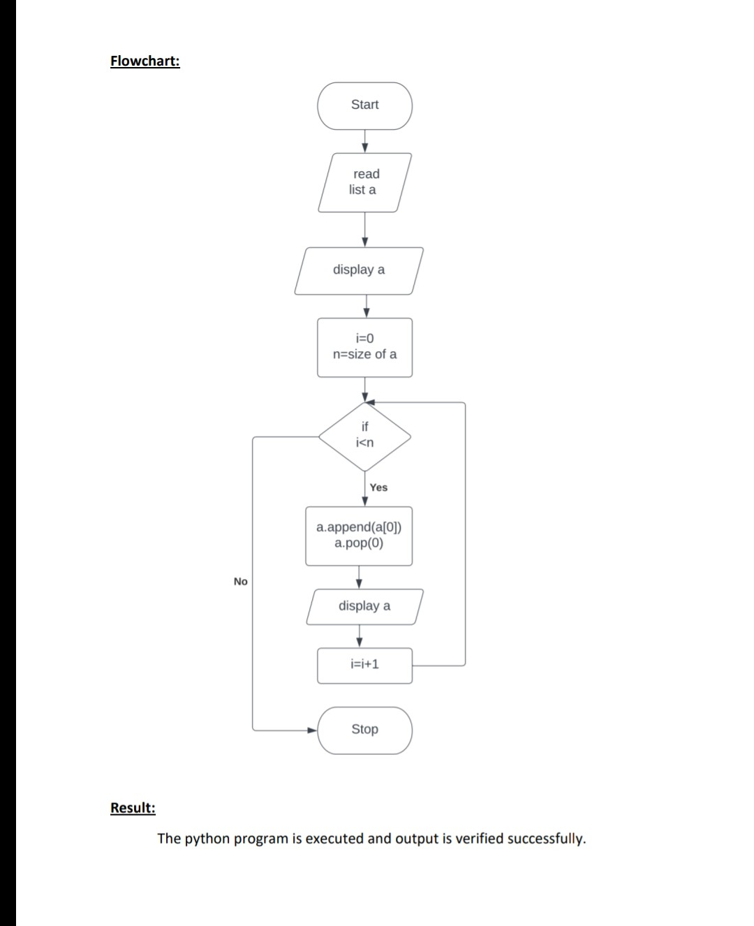

**f)CIRCULATING THE LIST OF VALUES USING SLICING OPERATOR(:)**

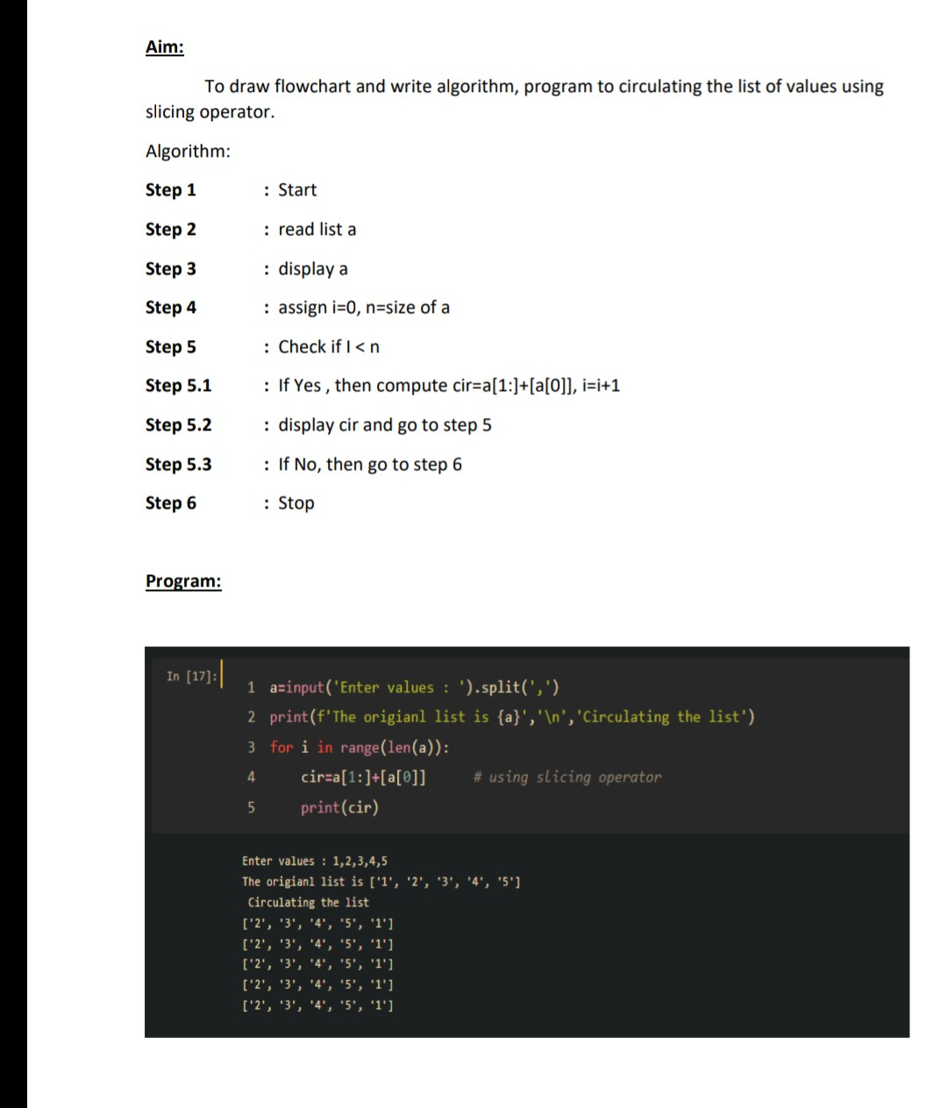

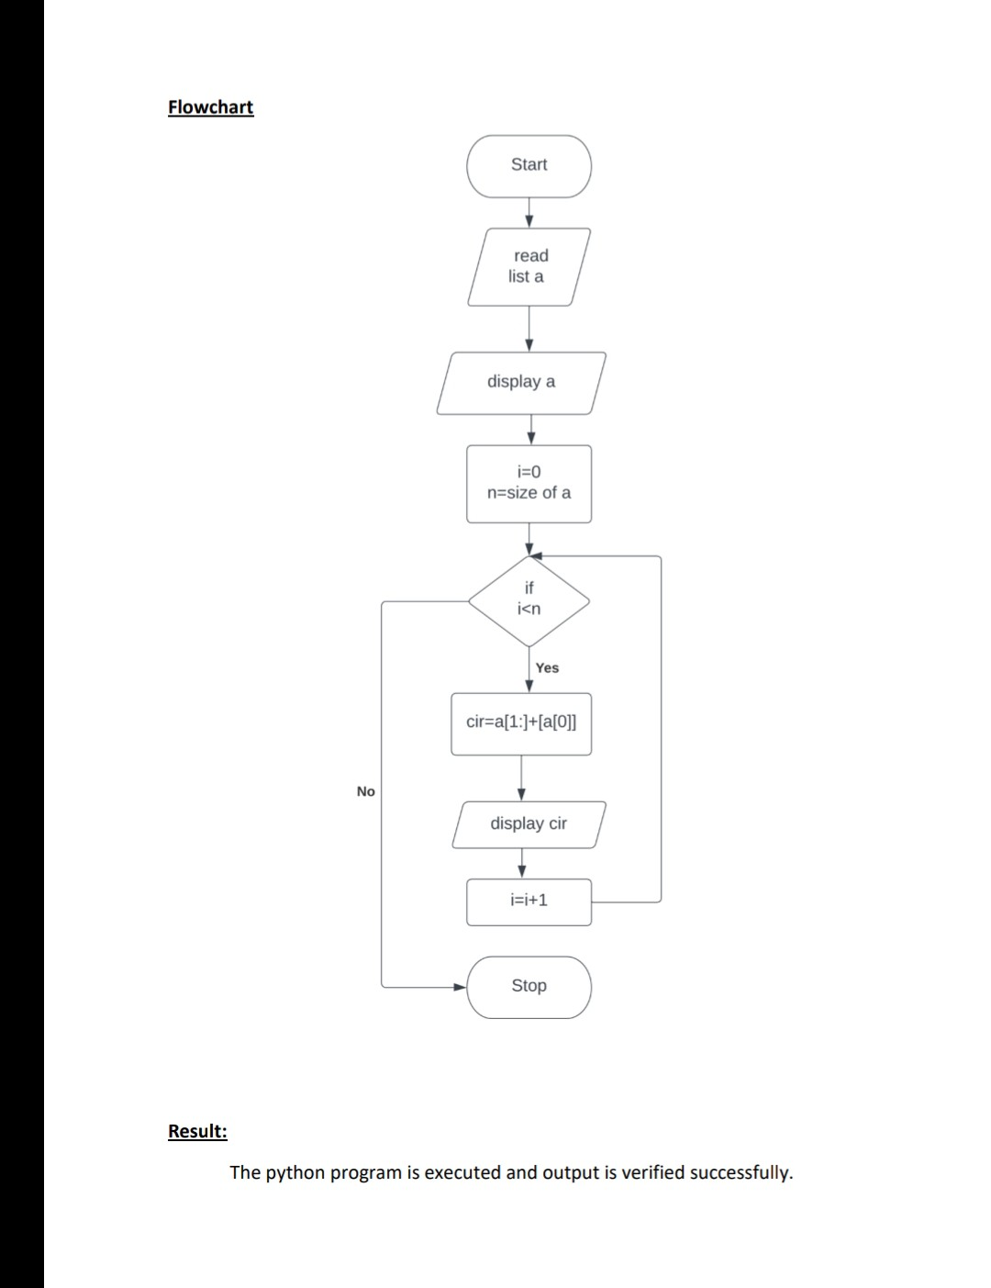

**g)CALCULATING THE DISTANCE BETWEEN TWO POINTS**

